## A

**Project Report on**

**Smart Notice Board.**

**Developed By**

***Nilesh Sharma[200511202055] Prince singh[200511202056]***

## as

**Partial Fulfillment of Semester III of Master of Computer Applications for A.Y. 2021 - 2022**

**Under the Guidance of Prof. Alka Choksi**

**Submitted To**

**Department of MCA Faculty of IT & Computer Science**

**PARUL University**





CERTIFICATE

This is to certify that **Mr. Nilesh Krishna Sharma, Enrollment No.200511202055 and Mr. Prince Ram Singh, Enrollment No. 200511202056** student of Master of Computer Applications has satisfactorily completed the Minor Project on **“Smart Notice Board”** at **Department of MCA, Parul University** as partial fulfillment of MCA Semester V.

Seat No. Date of Submission:

Internal Guide Project Coordinator Director - MCA

**Department of MCA Faculty of IT & Computer Science**

**PARUL University, Vadodara**

### Acknowledgement

The success and final outcome of this project required a lot of guidance and assistance from many people and we are extremely privileged to have got this all along with the completion of our project. All that we have done is only due to such supervision and assistance and we would not forget to thank them.

We owe our deep gratitude to our project guide Prof. Alka choksi (Prof., MCA), who took a keen interest in our project work and guided us all along, till the completion of our project work by providing all the necessary information for developing a good application.

We also like to thank Prof. Vivek Dave (Head of Department, MCA), Prof. Alka Choksi (Project Coordinator) for guiding, helping and providing the expert lectures whenever needed.

We are thankful for and fortunate enough to get constant encouragement, support, and guidance from our Parents, all Teaching staff of the MCA Department which helped us in successfully completing our project work. Also, we would like to extend our sincere esteems to all staff in the laboratory for their timely support.

Nilesh Sharma – 200511202055 Prince Singh- 200511202056

# INDEX

|  |  |  |
| --- | --- | --- |
| **No.** | **Description** | **Page No.** |
| **1.** | **About Department of MCA** | **1** |
| **2.** | **Project Profile**   * 1. Project Definition   2. Project Description   3. Existing System / Work Environment   4. Problem Statements   5. Need for New System   6. Proposed System & Features   7. Scope   8. Outcomes   9. Tools & Technology used   10. Project Plan | **2** |
| **3.** | **Requirement Analysis**   * 1. Feasibility Study   2. Module   3. Users of the System   4. Process Model   5. Hardware & Software Requirements   6. Use Case Diagram | **5** |
| **4.** | **Design**   * 1. Diagrams      1. Sequence Diagram      2. Class Diagram      3. Entity Relationship Diagram   2. Data Dictionary | **9** |
| **5.** | **Implementation**   * 1. Form Layouts   2. Report Layouts   3. Coding Convention (Business Logic) | **15** |
| **6.** | **Testing**   * 1. Test Strategy   2. Test Cases | **23** |
| **7.** | **Future Enhancement** | **29** |
| **8.** | **Bibliography** | **30** |

### About Department of MCA

**Parul University**

Parul University is a legitimate university established under Gujarat Private University Act 2009, after legislation passed by the Government of Gujarat on 26thMarch 2015 giving University status to Parul Group of Institutes functioning under the aegis of Parul Arogya Seva Mandal Trust.

### Faculty of IT & Computer Science

Faculty of IT and Computer Science, Parul University has materialized as one of the prime IT education providers at global level. Various departments under Faculty of IT and Computer Science strive in preparing IT-industry ready professionals by means of various skill development courses, vocational courses, co-curricular & extra-curricular activities, industry visits and expert lectures.

### MCA Department

The Department of Master of Computer Application at Parul University emphasizes on building professionals in the domain of computer applications by providing necessary environment by means of facilitating suitable blend of technical and non-technical learning experience. The department cultivates students in various curricular, co- curricular and extra-curricular activities in order to produce future system analysts, system designers, system programmers, application programmers, testing professionals, system managers, project managers, researchers and other leading positions in systems/IT department.

The department offers various subjects from diversified technical/non-technical areas such as – core IT domain, management, communication skills, mathematics & logic building and rich pool of elective subjects.

The department of MCA focuses on project-based learning, and hence students are motivated to work on tiny hands- on projects in practical oriented subjects to get better exposure. Moreover, throughout their MCA studies, students are required to work on around 3 mini/major projects in individual/team to get enough confidence on software- development and thereby become industry-ready.

### Project Definition

1. **Project Profile**
   * The aim of this project is to develop a wireless notice board that will be used at the faculty in order to display latest information.
   * The Online Notice Board System is intended for colleges and institutions where information and file sharing on regular basis plays vital role in the performance.
   * The Online Notice Board which will make use of the modern communication method and techniques for information flow.
   * The system is planned to consist of various useful features for the said purpose
   * So admin can leave and erase notification for other people to read and see.
   * The main aim of this free online notice board project is make information dissemination much easier in a paperless community as the world tends to interact with the online notice board facility as a project.

### Project Description

* + Nowadays every advertisement is going to be digital. The moving message display is used in college campus, universities to scroll different events and important notice.
  + A Notice Board is a surface intended to convey important news, announce events or provide information.
  + Aim to create this platform for issuing notice, sharing information and files between the members of the institution.
  + The administrator shall be able to issue notice, upload files and view students activities.
  + The students shall be able to see uploaded files, view general notices, personal notice, submit feedback. A guest will simply be able to view public notices.
  + The primary aim of the Online Notice Board software project is to create a user-friendly interface and digital system which will efficiently handle all assigned tasks instead physical notice board.
  + Make the system a distributed system accessible to many devices.
  + This web application invoice almost all the features of online notice board
  + In the online notice board project all update like, add, delete, view is done by admin, so that user will get the update current information through notice board online

### Existing System

The Existing System consist of paper based notice which has been carried by the human. Due to this reason, it has some disadvantages;

* + The paper file has to be stored in sorted form and manage them.
  + The searching is very difficult to view a particular paper.
  + Sometimes the notice paper may be damaged due to weather (eventually happens in rainy season).

### Problem Statement

Now this digital world many people have access to modern technology. The Smart notice board is outdated and has many limitations.

Examples:

* + It is hard to know latest posts.
  + You don’t have direct access to the people who post the notice.
  + Difficult to keep checking the notice board for new post.
  + It is not normally accessible with their limitation which around us the normal notice board

### Proposed System

* + The proposed system aims to create a platform for issuing notice, sharing information, admission forms details. Different users shall have different content.
  + Students can see general notice, personal notice, feedback (query or any other message) send to the administrator.
  + The administrator able to issue notice, upload files, view students activity, manage students, manage notice.
  + The guest will simply be able to view public or general notice.

### Scope

* + We can provide SMS based integration for registration confirmation.
  + Send results through an email to registered students and updated notice by an admin.
  + It is the web-based application software that aims to aid the institutes by providing such digital notice board.

### Tools & Technology used with short justification:

**Tools and Technology:**

* + Front end: HTML, CSS, JQuery, Bootstrap
  + Middle end: PHP
  + Back end: MySQL

### Justification:

* + The system will reduce energy and time spent checking the notice board.
  + User can be responding to the post.
  + It will give user ability to filter notice or post according to the subject or particular topics.
  + It will minimize cost used to print papers and used for posting to a normal notice board.

### Project Plan

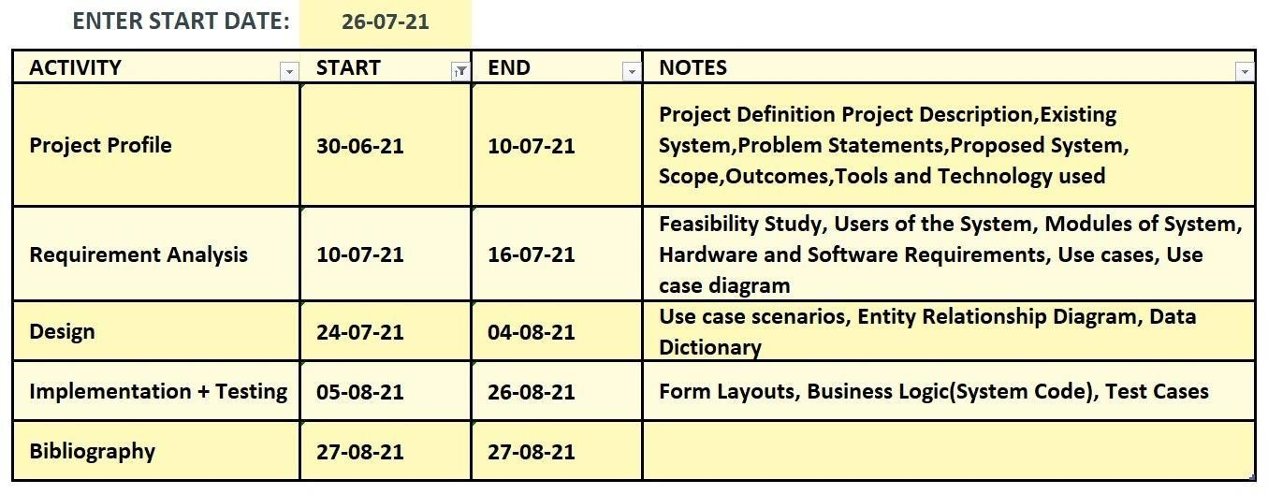

Fig 2.9 Timeline Chart

### Requirement Analysis

* 1. **Feasibility Study**

A feasibility analysis involves a detailed assessment of the need, value and practicality of a proposed enterprise, such as systems development. The process of designing and implementing record keeping systems has significant accountability and resource implications for an organization. Feasibility analysis will help you make informed and transparent decisions at crucial points during the developmental process to determine whether it is operationally, economically and technically realistic to proceed with a particular course of action. Most feasibility studies are distinguished for both users and analysts. First, the study often presupposes than when the feasibility document is being prepared, the analyst is in a position to evaluate solutions. second most studies tend to overlook the confusion inherent in system development – the constraints the assumed attitudes.

### Operational feasibility

People are inherently resistant to change, and computers have been known to facilitate change. An estimate should be made of how strong a reaction the user staff is likely to have toward the development of a computerized system. It is common knowledge that computer installations have something to do with turnover, transfers, retraining, and changes in employee job status. Therefore, it is understood that the introduction of a candidate system requires special effort to educate, sell and train the staff on new ways of conducting business.

### Technical feasibility

Technical feasibility centers around the existing computer system (hardware, software, etc.) and to what extent it can support the proposed addition. For example, if the current computer is operating at 80 percent capacity – an arbitrary ceiling – then running another application could overload the system or enhancements. If the budget is a serious constraint, then the project is judged not feasible.

### Module used:

* Registration module
* Login module
* About us module
* Contact us module
* Ask me module

### Users of the System:

* Admin
* Teacher
* Student
* Guest/User

### Admin

Admin is the people who control, monitors and keeps the wholes follow of the system. the main function of the Admin is:

* Can add, activate and deactivate any user.
* Add new notice and send notice to registered users
* Display old notice and manage old notice
* Update password

### Student

Update password The student is knowledge seeker, or more theoretical word, a learner. The student has to be registered and log in into the system before he/she carries out their function

* Student Registration
* Login
* Check Notification sent by admin
* Update Profile
* Update Password
* Log out the whole system

### Teacher Module

* + - * Teacher Registration
      * Login
      * Check Notification sent by admin
      * Add new notice and send notice to registered Student
      * Update Profile
      * Update Password
      * Log out the whole system

### User Module

* Check Notification sent by admin.

### Hardware & Software Requirement: Hardware

* 233 MHz processor
* 128MB SD-RAM
* 2-4GB HARD-DISK.
* 4*Compact Disk drive or quicker.
* 1.44 B Floppy Disk Drive.
* Monitor. [640*480 Display] Front End-PHP

### Software:

* Front End-PHP
* Back End – MYSQL
* Server – Apache server
* Design Tool – Macromedia Dreamweaver
* Documentation Tool – Microsoft word

### Use Case Diagram:

Login

Upload Notice

Student

View Notice

Delete

Give Feedback

Logout

Teacher

Admin

###### s

Guest/User

Fig 3.5: Use case Diagram

### Sequence Diagram:

Enter Details

Get User ID/Password

Enter User Id/ Password

Authentication

View Notice

Generate Notice

User Feedback

User Feedback

View Notice

Login

Register

Student / Teacher

Fig:4.1Sequence Diagram

Admin

Login

Manage Notice

Upload/Upadate/Delete Notice

Action Perform on Notice

Enter User Id/ Password

Authentication

### Class Diagram:

**Student**

-name: char

-branch: varchar

-sem: varchar

-mob: int

-gender: varchar

-dob: datetime

-regid: int #username: varchar #pwd: password

-status: varchar

+sid: int

+viewnotice()

#### M

**Register**

**Teacher**

##### Database

###### +admindata()

+studentdata()

+teacherdata()

-name: char

-mob: int

-email: char

-dob: char

-branch: char

-sem: varchar #username: varchar #pwd: password

-name: varchar

-mob: int

-branch: varchar

-status: varchar

# username: varchar #pwd: password

+tid: int

+viewnotice

**Logout**

|  |
| --- |
| **Login** |
| -username: varchar  -pwd: password |
| +login()  +logout()  +register() |

+admin

+student()

+teacher()

**Admin**

1

# username:varchar #pwd: password

-email: char

-mob: int

+aid: int

+uploadnotice()

+deletenotice()

+viewnotice()

+updatenotice()



**View Notice**

* 1. Class Diagram:

-nid: int

-notice: long

-noticedate: datetime

-branch: char

-sem: varchar

+admin()

+student()

+teacher()

* 1. **E- R Diagram:**

1 M

ID

E-mail

Password

Admin

ID

Sem_no

Name

Teacher

Manage

1

1 M

Manage

Manage

Add

M

M M

M view M

Student

Notice

ID

E-mail

N_ ID

Descriptio

Sem

Password

Name

Fig 4.3 E-R Diagram

N_data

Department

* 1. **Data Dictionary:**
     + **Admin**

|  |  |  |  |  |
| --- | --- | --- | --- | --- |
| **Name** | **Data type** | **Field Size** | **Description** | **Example** |
| ID | Int | 11 | Unique number id for Admin | 1111 |
| User | Varchar | 50 | User name to Admin | prince@123 |
| Password | Varchar | 20 | Password for Security | ********* |

**Table 1**

* + - **Teacher**

|  |  |  |  |  |
| --- | --- | --- | --- | --- |
| **Name** | **Data type** | **Field Size** | **Description** | **Example** |
| ID | int | 11 | Unique number id for Teacher | 1010 |
| Name | Varchar | 100 | Teacher name | Nilesh |
| Mob_no | Varchar | 12 | Teacher mobile number | 959554555 |
| E-mail | Varchar | 100 | Teacher e mail | nilrsh@gmail |
| Branch | Varchar | 10 | Teacher Branch | MCA |
| Password | Varchar | 30 | Password for Security | ******** |
| Img | Varchar | 200 | Store the data img |  |

**Table 2**

* + - **Student:**

|  |  |  |  |  |
| --- | --- | --- | --- | --- |
| **Name** | **Data type** | **Field Size** | **Description** | **Example** |
| S_no | Int | 11 | Unique number id for Student | 655 |
| Name | Varchar | 100 | Name of Student | xyz |
| E-mail | Varchar | 100 | E-mail of student | xyz@ |
| Subject | Varchar | 200 | Subject marks is dispaly | 875 |
| Message | Varchar | 200 | Message will be connect | I am good |

* + - **Notice**

**Table 3**

|  |  |  |  |  |
| --- | --- | --- | --- | --- |
| **Name** | **Data type** | **Field Size** | **Description** | **Example** |
| Notice_id | Int | 11 | Admin/Teacher will be given to  All ID Notice to selected ID | All/784 |
| Branch | Varchar | 100 | Notice will be given to all  Branch As per selected branch | All/MCA |
| Sem | Varchar | 100 | We will give All sem to notice | All/3 |
| Subject | Varchar | 100 | Notice of Exam subject | All |
| file | Varchar | 100 | Notice will be file | All |

**Table 4**

* + - **Feedback**

|  |  |  |  |  |
| --- | --- | --- | --- | --- |
| **Name** | **Data type** | **Field Size** | **Description** | **Example** |
| S_no | Int | 11 | Feedback all ID member | 876 |
| Name | Varchar | 100 | Name will be mension those is  give Feedback | XYZ |
| E-mail | Varchar | 100 | E-mail will be mension those is  give Feedback | XYZ@ |
| Subject | Varchar | 200 | Feedback of Subject | Xyz is good |
| Message | Varchar | 200 | Any message | xyz |
| Datatime | Varchar | 50 | Date of feedback | 15/12/2021 |

**Table 5**

**5. Implementation**

* 1. **Form Layouts:**

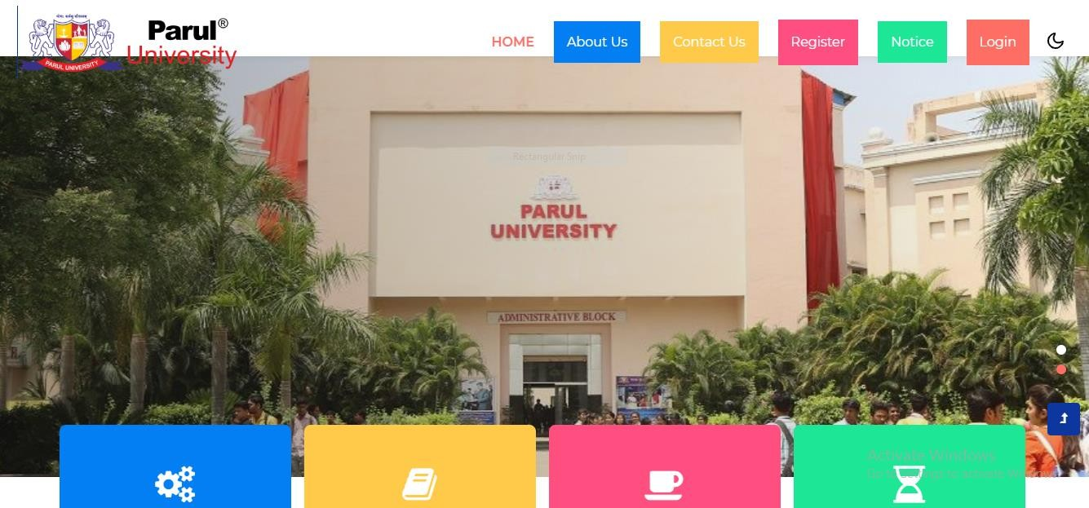



Fig5.1 Home page.



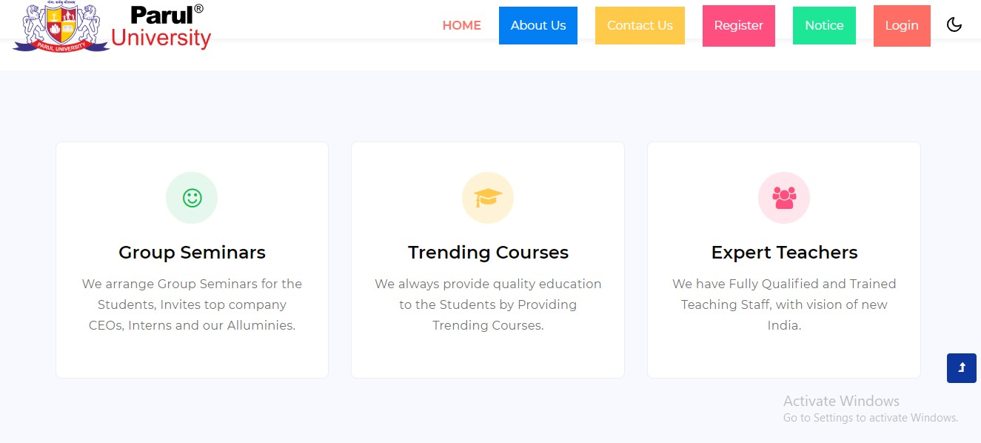

Fig 5.1.2 University About.

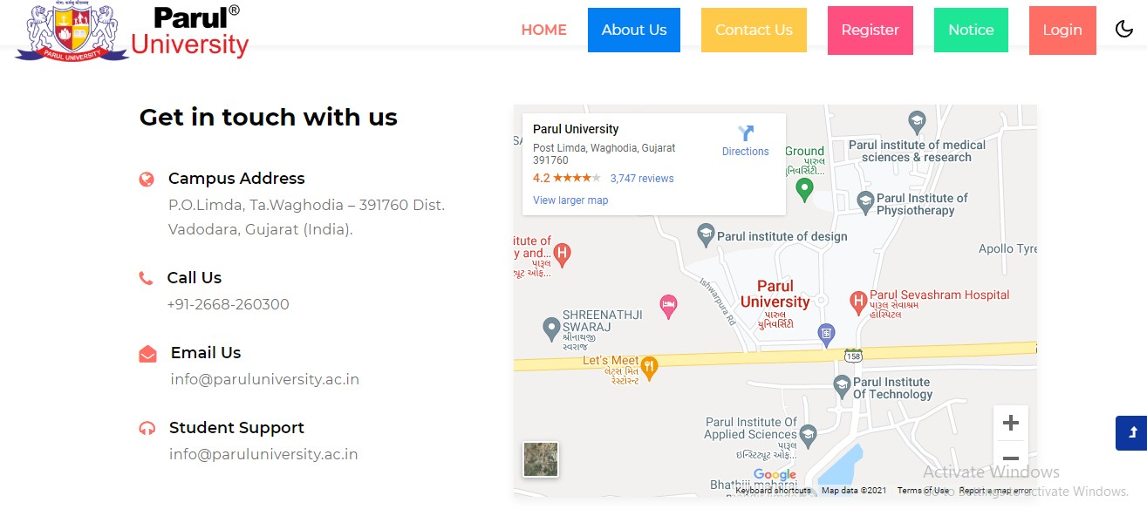

Fig 5.1.3 Contact us.

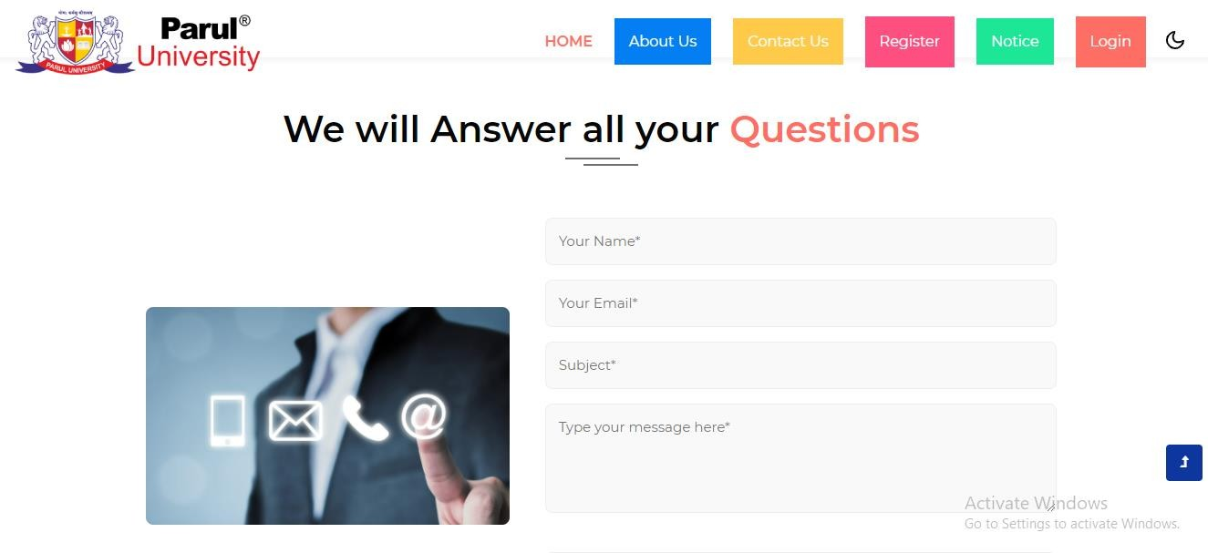

Fig 5.1.4 Feedback User.

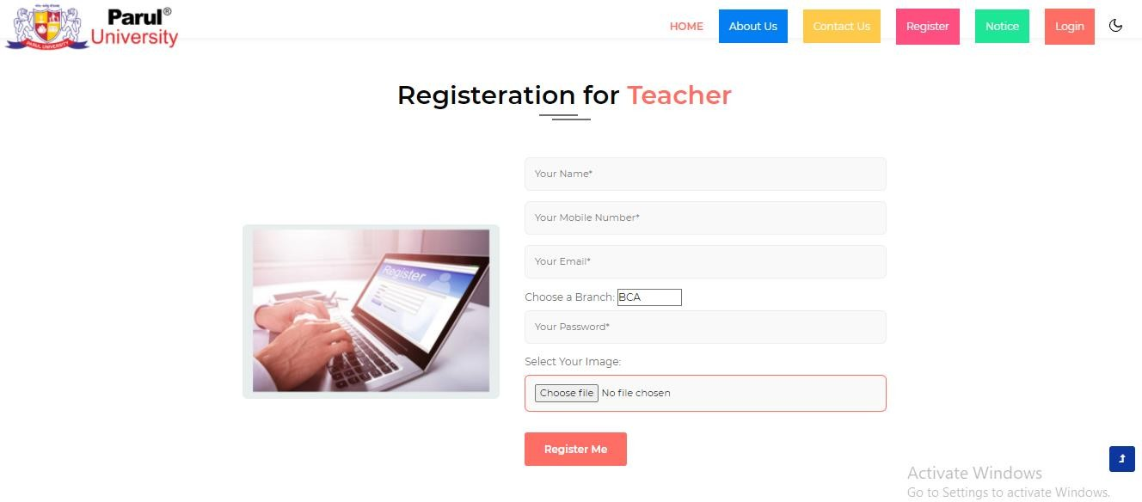

Fig 5.1.5 Registration for Teacher.

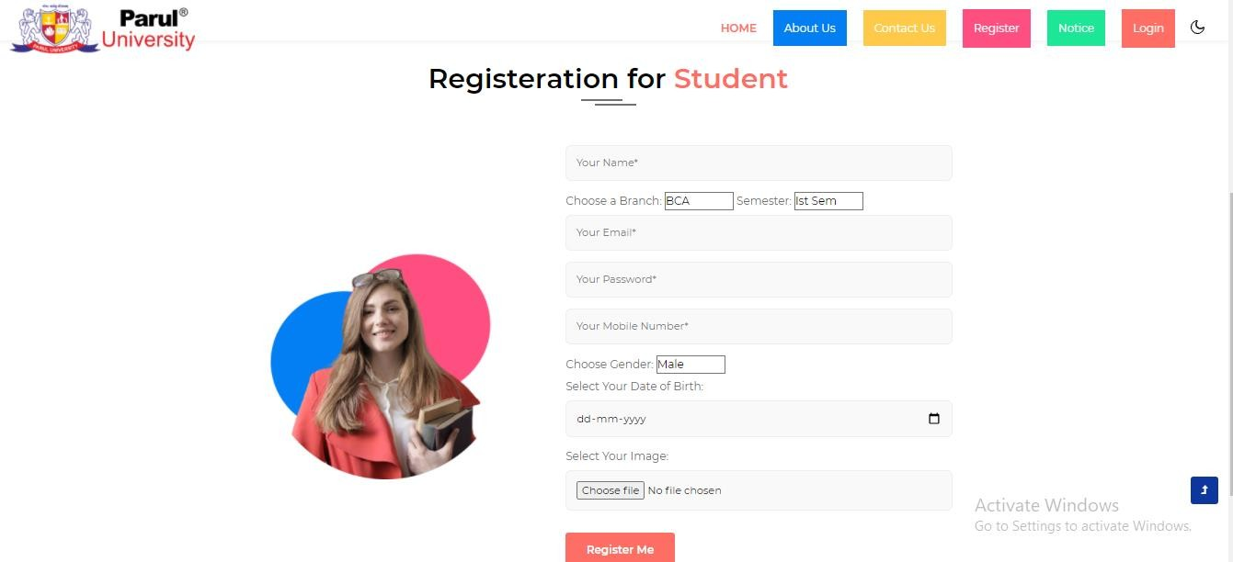

Fig 5.1.6 Registration for Student.

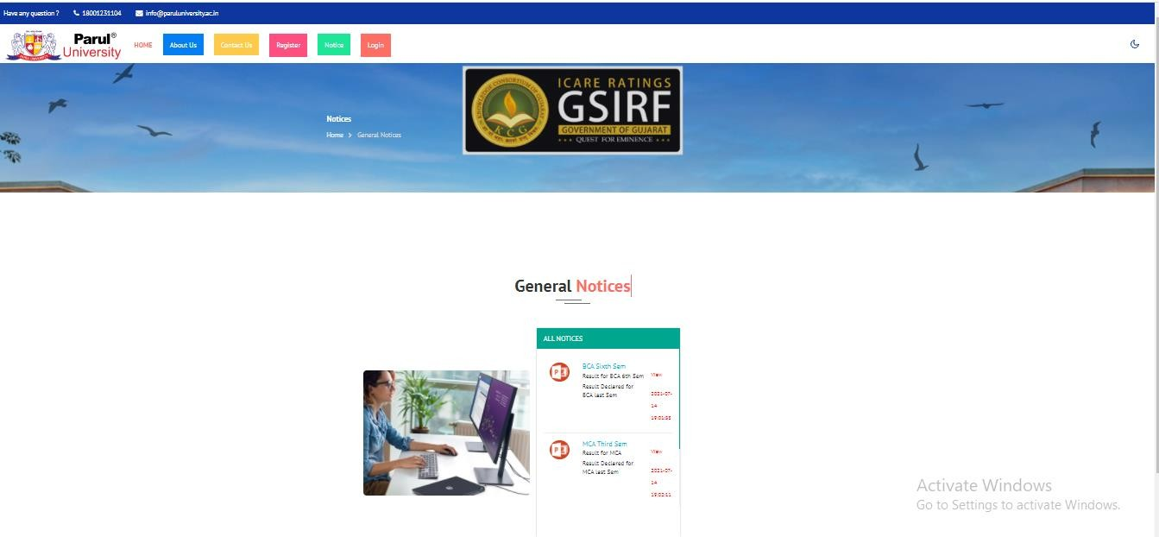

Fig 5.1.7 All Notice.

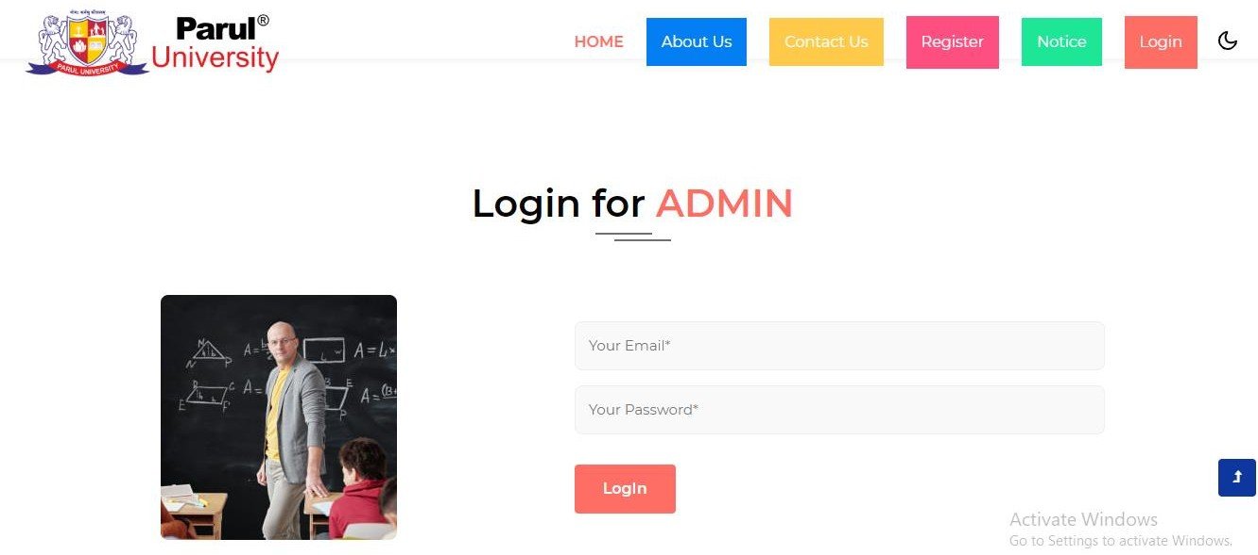

Fig 5.1.8 Login for Admin.

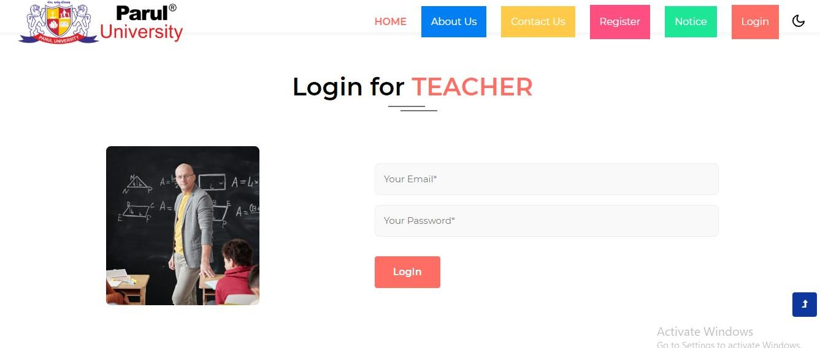

Fig 5.1.9 Login for Teacher.

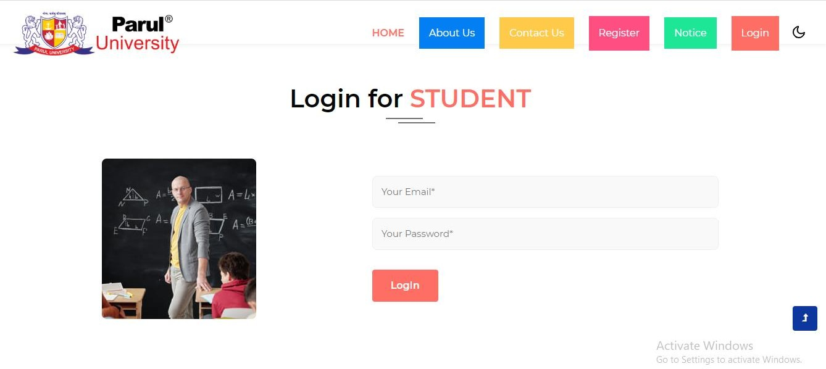

Fig 5.1.8 Login for Student.

### Report Layouts:

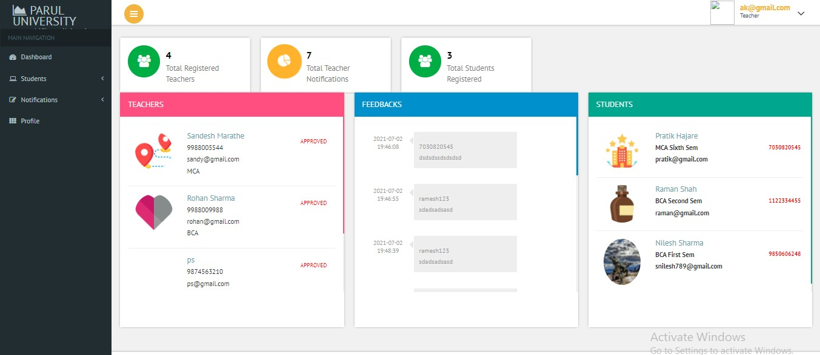

Fig 5.2.1 Teacher Profile.

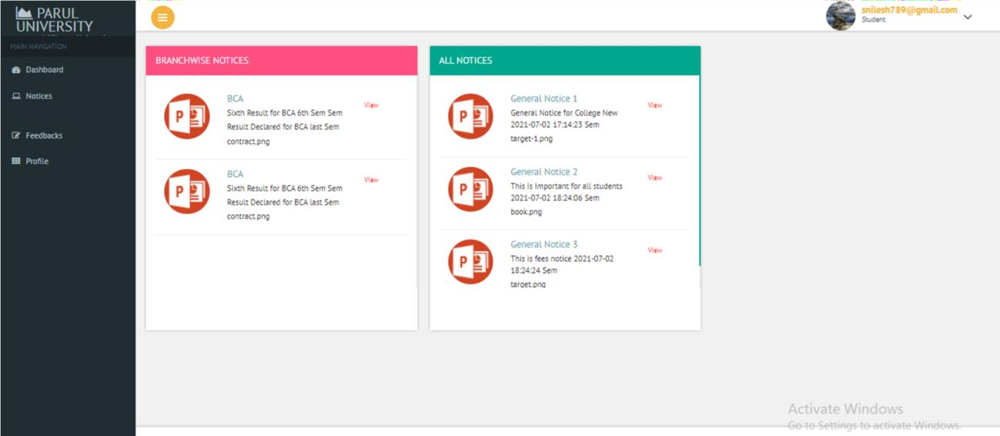

Fig 5.2.2 Student Profile.

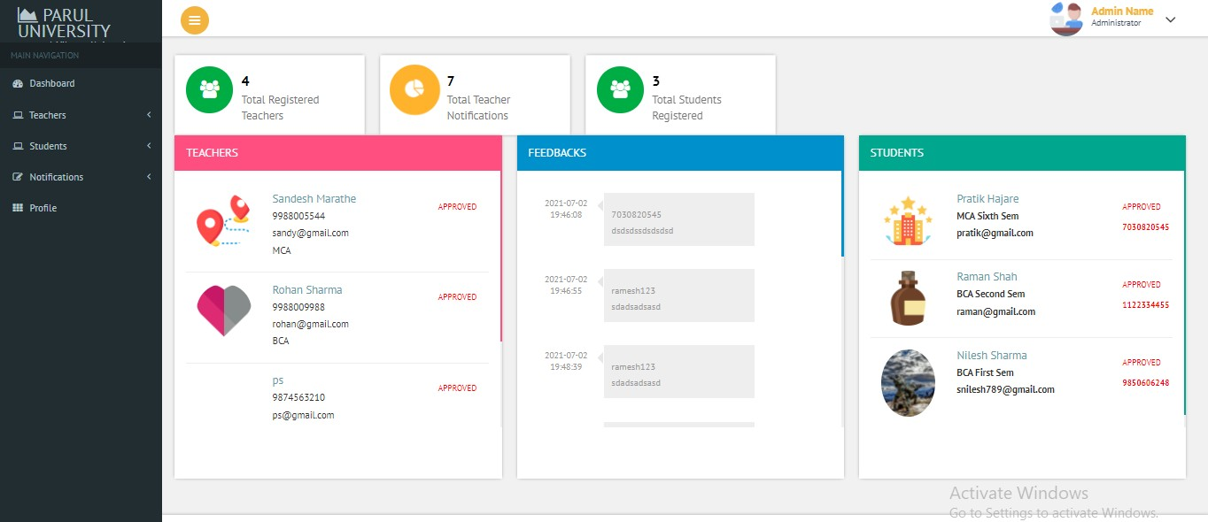

Fig 5.2.3 Admin Profile.

### 6.1 Testing

* 1. **Test Strategy**

In ourscenario, testing strategy is used to testthe functionality of our system. We havetouseto cover all scenario. MainfocusisonFunctionalTesting.InFunctionalTestingtestcaseareusedtotestthe applicationinterface.

Inoursystem,testingisgoingtobedoneatindividual(Unit)modulelevel.Eachmodulewillbe undergonetoUnit testing (One Module) and expected result is supposed to be same as actual result

### Admin Login

|  |  |
| --- | --- |
| **Test Case Summary** | This test case was conducted for checking login. |
| **Prerequisite** | Admin must be registered in system**.** |
| **Test Procedure** | * Enter email and password. * Check the email and password is correct or not. * Admin change status |
| **Test Data** | [Email:ps@gmail.com](mailto:ps@gmail.com)  Password: **** |
| **Expected Result** | Admin enters into the system |
| **Actual Result** | Admin can view the all Dashboard. |
| **Status** | Pass |
| **Remark** | This test case is for login into the system. |
| **Test Environment** | Chrome Browser |

##### Table 6.1

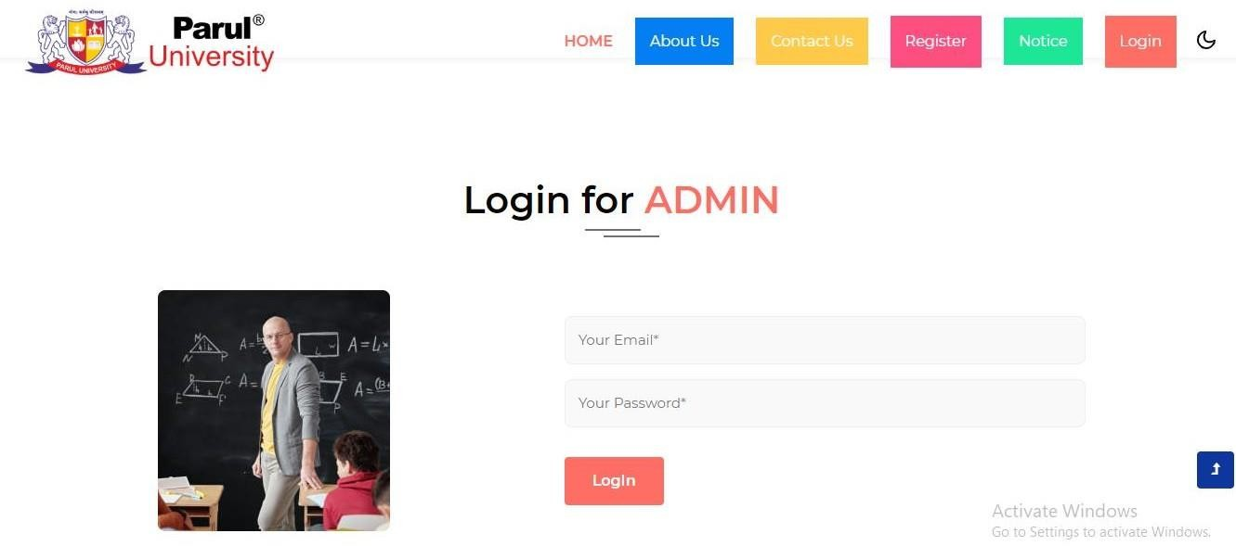

**Fig: 6.1 Admin**

* + 1. **Teacher Login**

|  |  |
| --- | --- |
| **Test Case Summary** | This test case was conducted for checking login. |
| **Prerequisite** | Teacher must be registered in system**.** |
| **Test Procedure** | * Enter email and password. * Check the email and password is correct or not. * Click on login button**.** |
| **Test Data** | [Email:Teacher@gmail.com](mailto:Teacher@gmail.com)  Password: **** |
| **Expected Result** | Teacher enters into the system |
| **Actual Result** | Teacher can view the all Dashboard. |
| **Status** | Pass |
| **Remark** | This test case is for login into the system. |
| **Test Environment** | Chrome Browser |

**Table 6.2**

**Fig 6.2 Teacher Login**

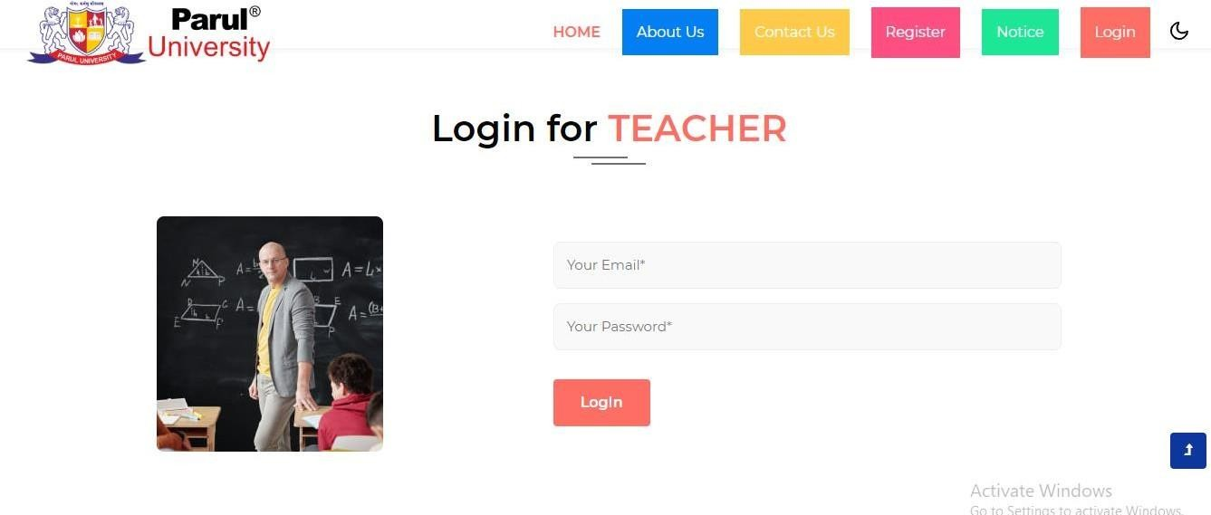

* + 1. **Student Login**

|  |  |
| --- | --- |
| **Test Case Summary** | This test case was conducted for checking login. |
| **Prerequisite** | Student must be registered in system**.** |
| **Test Procedure** | * Enter email and password. * Check the email and password is correct or not. * Click on login button**.** |
| **Test Data** | [Email:ps@gmail.com](mailto:ps@gmail.com)  Password: **** |
| **Expected Result** | Admin enters into the system |
| **Actual Result** | registration will be approved |
| **Status** | Pass |
| **Remark** | This test case is for login into the system. |
| **Test Environment** | Chrome Browser |

**Table 6.3**

**Fig 6.3 Student Login**

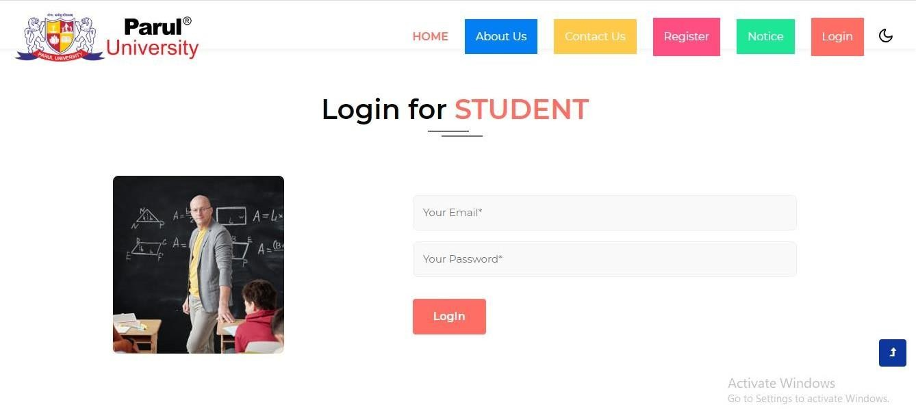

* + 1. **Registration**

|  |  |
| --- | --- |
| **Test Case Summary** | This test case was registration of teacher student |
| **Prerequisite** | All member must be registered in system**.** |
| **Test Procedure** | * Fill registration form * Click on registration button**.** * After registration get email and password |
| **Test Data** | [Email:ps@gmail.com](mailto:ps@gmail.com)  Password: **** |
| **Expected Result** | Admin enters into the system |
| **Actual Result** | Admin can view the all Dashboard. |
| **Status** | Pass |
| **Remark** | This test case is for login into the system. |
| **Test Environment** | Chrome Browser |

**Table 6.4**

**Fig 6.4 Registration for Teacher**

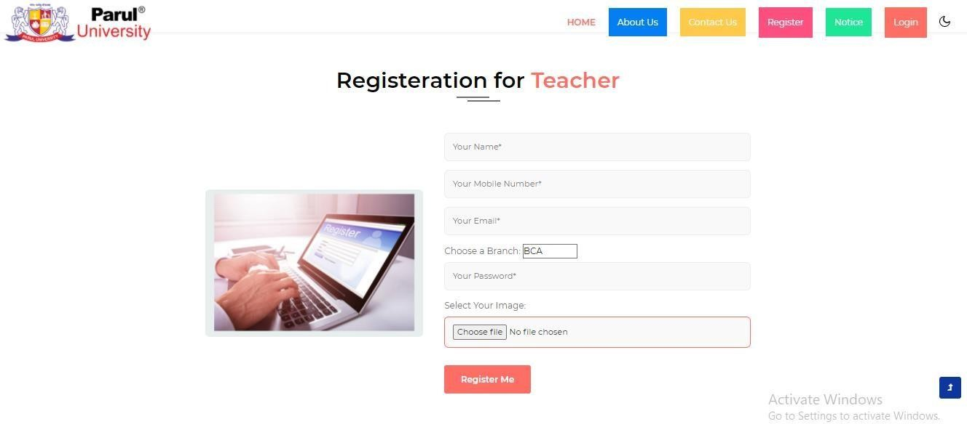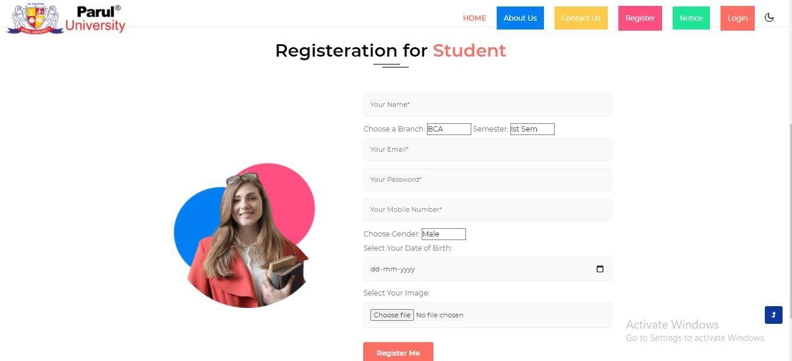

**Fig 6.4.1 Registration for Student**

* + 1. **Add Notice**

|  |  |
| --- | --- |
| **Test Case Summary** | This test case use for add notices admin the notice |
| **Prerequisite** | Admin add the notice |
| **Test Procedure** | * Click add newnoticeor updatenoticeor enter data * Click on update |
| **Actual Result** | Notice Add Successfully |
| **Status** | pass |

**Table 6.5**

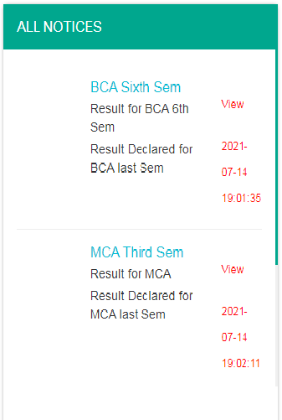

**Fig 6.5 Add Notice**

29

1. **Future Enhancement**

This website which will be useful for students, teachers and other users to get notice and information and also ask questions or send any feedback directly to the admin.

**In future, we wish to implement the following ideas-**

* + - * We can provide sms and email based integration for registration confirmation.
      * Send results as an email to registered students and send sms alerts whenever results are sent to email or updated. Alerting module can be worked out in future.
      * We need to introduce a compression tool for the images in the database so that the website speeds up.
      * We will be improving the theme of the website to give a more classy and attractive look.

### Smart Notice Board

30

**Bibliography 2021 - 2022**

1. **Bibliography**
   * + - [www.github.com](http://www.github.com/)
       - https:/[/w](http://www.phptpoint.com/)w[w.phptpoint.com/](http://www.phptpoint.com/)
       - https:/[/w](http://www.beingstudy.com/)w[w.beingstudy.com/](http://www.beingstudy.com/)
       - <https://www.scribd.com>
       - <https://www.sourcecodester.com>
       - https://www.youTube.com

### Smart Notice Board